Study Two, Week Three
Foundational Principle
“Love your neighbor as yourself”

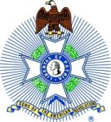

In his letter to the believers in Ephesus, the Apostle Paul wrote (Ephesians 5:29), “For no one ever hated his own flesh, but nourishes and cherishes it.”
We are reminded that part of our job, our calling, our responsibility is to care for others just as much as we care for ourselves.
It is easy to look about today and see plenty of negative examples. We get easily irritated by people who seem to be focused only on themselves. The person who goes to the famed seafood buffet at the local restaurant and takes a plate full of your favorite delicacies – and leaving none for you. The driver that is not paying attention and cuts you off on the interstate highway. A person paying more attention to a cell phone than he is to his driving or walking and hits into you.
If you watched the series, TURN, about the Revolutionary War, you probably had a similar reaction to a spy catcher, Major Simcoe. A particularly ruthless British Officer, he seemed to have no mercy on anyone. Sometimes even his own officers.
The British were well known for their horrible treatment aboard their prison ships off the coast of America. The imprisoned men, and some women, were badly treated at best. Many prisoners died within a year of their incarceration due to the horrific conditions and inhumane treatment aboard those ships.
Even during the important Revolutionary War, that treatment of prisoners of war was contrary to the way that General Washington acted. Washington had a deep respect for all life, even in war. He was reluctant to kill anyone or do them harm. But if it was necessary, as in war, it then became his obligation to do so that he may survive.
We read in Luke 10 about the Good Samaritan. A man was traveling along the road. Thieves came upon him, he was beaten, robbed, and left for dead. Two of the community leaders saw the injured man and passed by on the other side of the road. However, a hated man cared for the injured man with funds from his own pocket.
Caring for poor and injured travelers gave rise to some movements during the 10th and 11th centuries. Especially well known were the Knights of the Hospital of St John of Jerusalem, or Knights Hospitaller. They were charged with the care and protection of travelers. They had sworn an oath to protect the travelers no matter what. They carried just one offensive weapon, a sword, to be used only in matters that threatened the lives of themselves or other travelers. They were to care for and protect travelers and guide them safely to their journey’s end.
Shepherds for centuries have carried a special crooked stick. It was a multipurpose tool for saving an animal who wandered into the rocks or fell off a cliff. The crook was used to pull the injured animal to safety. The crook was also swung at wild animals that attacked the sheep. Finally, it was used as a walking stick.

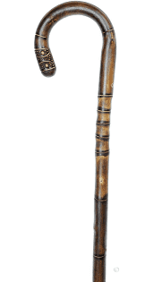

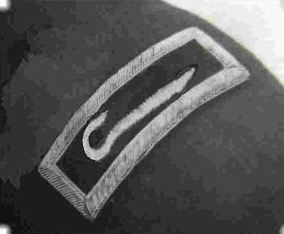

We are like the Knights of the Hospital of St John of Jerusalem. We care for travelers along the road to true freedom, guiding them, helping them to learn the basic principles of freedom and liberty. We go into schools and teach as much as we can about the Revolutionary War.
We have poster contests to highlight events of the period. We hold the Rumbaugh Oration Contests, and several other events for youth. We honor the Military, EMS, Firemen, and Police for their service to humanity. These events are just a small part of what we do as SAR Gentlemen while we travel the road of freedom, guiding, and helping others on their journey to understand freedom and liberty. The programs become our examples to teach the basic principles of freedom and liberty.
However, that does not complete the words of the Second meaning of our emblem, the SAR Cross. Do you remember the Bible story of the Good Samaritan? It is about how a hated man came upon a man beaten and left for dead? Consider the lessons taught. (Luke 10:29-37, The Parable of the Good Samaritan.) The Knights of St. John of Jerusalem based their ministry on this biblical narrative which teaches us the way to freedom and liberty is through compassion and service to others. This is what our Great and Wonderful God urges us to do for our fellow travelers who seek the true meaning of freedom and liberty. These actions demonstrate the outward action of the inward virtues of “A SAR Gentleman.”

2021
We are to reach out to those in need of understanding the basic principles of freedom and liberty and help them learn as we are able.
Teaching history of battles, clothing, and weapons in schools.
Marching in Parades and honoring Veterans in period dress.
Honoring Patriots and our own fallen members.
Helping the public understand what freedom really is.
Helping men find their ancestors who played a part in the struggle for freedom and liberty in this great land.
Making in-person presentations as they are possible to present awards for contests, for proper flag etiquette, for serving the community.
Marking graves of veterans at Christmas and Memorial Day.
Dedicating graves of patriots who gave their lives for our freedom.

Take a few moments to quietly think about how you and your chapter reach out to support others.
Perhaps you may want to jot down a few personal notes for future reference.
Every now and then it may be good to review what you have written to gauge your growth. That backward glance may offer some insight in how you reach out to others and show compassion in their struggle to find the true meanings of freedom and liberty.

Questions for growth.
What do you do to display a clear example to others that shows something about the true meaning of freedom and liberty?
How do you act that displays to others your inner commitment to freedom and liberty?
How does your chapter participate in showing clear examples of promoting the principles of freedom and liberty?
What sorts of programs and activities do you have to promote freedom and liberty?
Do you and your chapter work with other groups to help them promote the basic principles of freedom and liberty?
Do you participate in honoring veterans, especially patriots?
In what programs do you participate?
Do you honor those who, like you, support and teach the principles of freedom and liberty?
How can you make good use of time, talents, and resources to further the goals and mission of the SAR in your area to reach out to others who struggle with understanding the basic principles of freedom and liberty?
The Second great meaning of the Maltese cross, the SAR Emblem is:
“Love your neighbor as yourself”

