2021
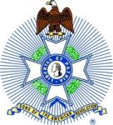
Study One, Week Two
Learning Love and Trust.
We must learn that love requires trust. We must learn to trust an all-powerful God that we cannot see. We must learn that the Sovereign Creator and ruler of the universe loves us and will guide us as we bow before Him.
Just as we love our families, our awesome God loves us jealously and will do everything necessary, in the right way to preserve us, show us His love, and care for us. – Forever.
Washington knew that the desires of his heart tended to be very self-centered. He struggled all his life to change that, to put God first. We can learn to do the same.
General Washington knew that authority requires respect. He learned that he, too must respect the authority of a great, sovereign God who would work out all the pieces of the puzzle and fit them all together the correct way. He also had to respect the authority of his officers. That respect was a powerful example to the men.
Washington knew that everything about the war did not depend on him alone. He understood that he must do his part to the best of his ability. He also knew that he must allow and encourage his officers and their men to do the same. Learning to show love, trust and respect are areas that we must work on if we expect to be exemplary and effective leaders. This is part of “Love the Lord your God”.
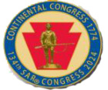
2021
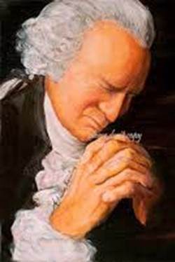
Quietly, in your private place, work on these things.
Put God first in everything.
Acknowledge His Authority.
Respect and Honor His Position and right to do what He does for His reasons.
Respect and honor your compatriots, both fellows and officers as they try to do the same.
Learn how much God loves you and the gifts he has given you.
Learn how to use this great love to share with your Society brothers.
Following these actions will encourage the seeds of hope to take root in your soul.
