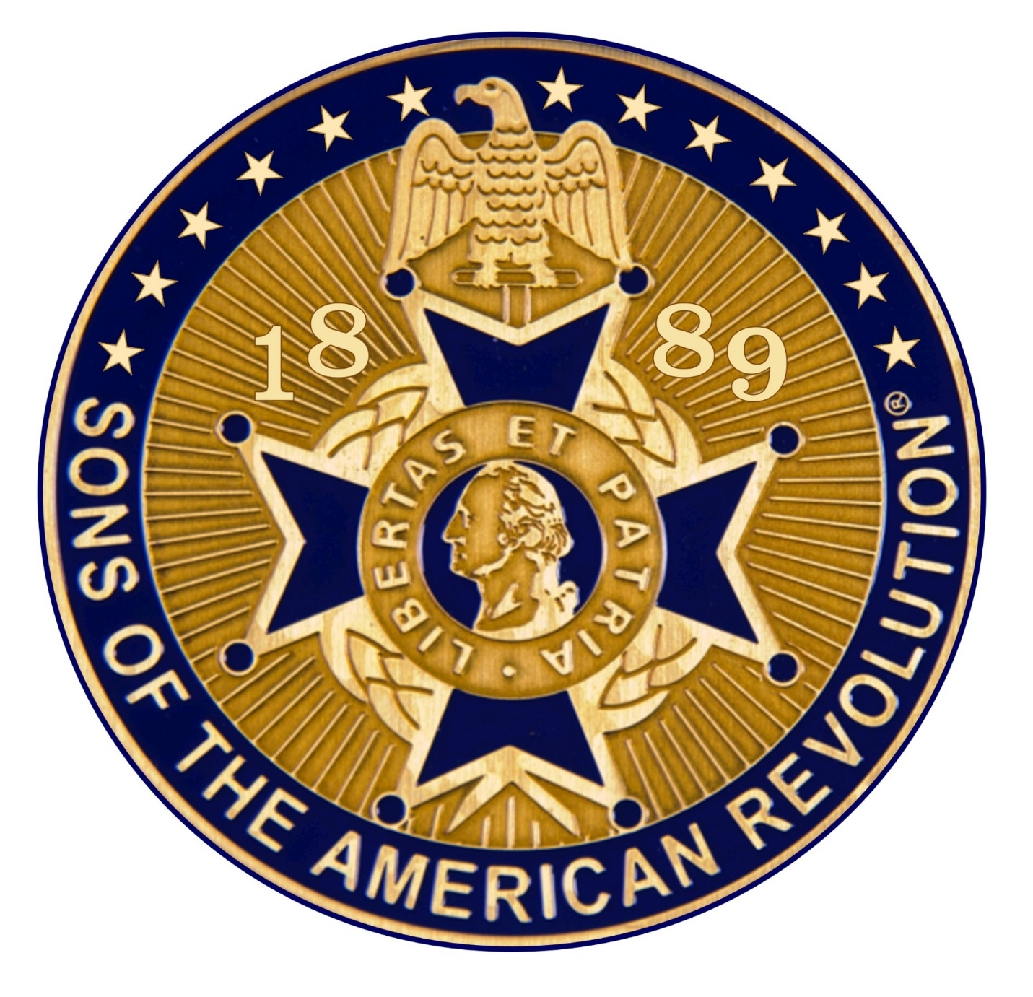
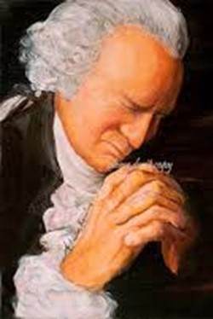
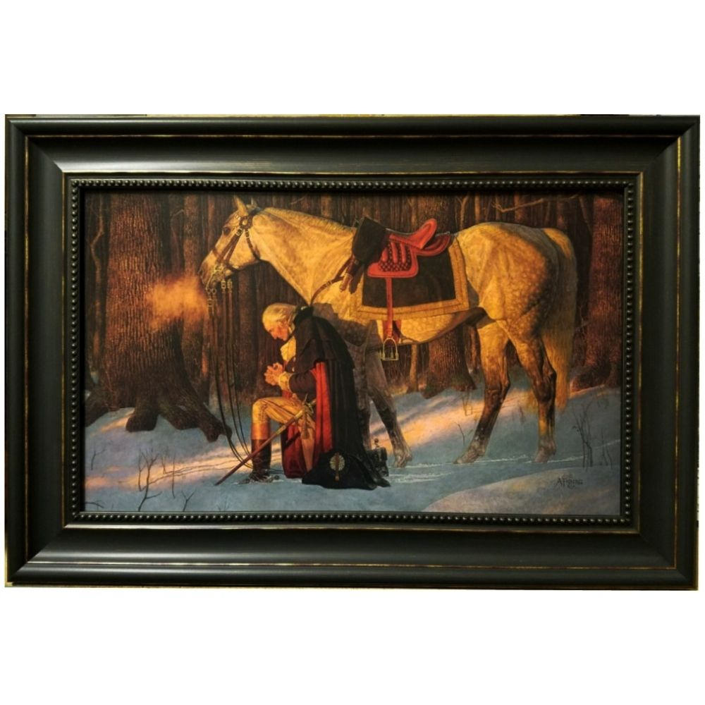
A SAR Gentleman

A Devotional Look at the SAR Cross
Officer Development Materials

Developed for PASSAR

The Pennsylvania Society
Sons of the American Revolution

For use by State and Chapter Officers
And ALL members
Who wish to become

A S A R Gentleman

Developed by:

Rev David J Felts, - Rev Robert K. Grumbling Jr., - Rev Dr William Hearter

PASSAR Chaplains

2021
Introduction

The purpose of this devotional look at the SAR Cross is twofold:

1: to offer an uplifting, devotional insight into the meaning of the SAR Maltese Cross for our growth and development as
A SAR Gentleman.

2: to deepen our walk with God to more than a cursory mention of God a few times a day. As we carry out that purpose, with daily study and meditation,
we will righteously impact ourselves, Chapters, PASSAR, the National Society,
our families, nation, and the world.

Each group under discussion is built upon the previous group. We need to follow the flow carefully so that we may accomplish lasting results.

May the God who led General George Washington to victory be gracious to you in your spiritual journey toward “A SAR Gentleman.”

DJF
Rochester, PA
2021

2021

Overview of Foundational Meanings

The SAR Cross is based on the Maltese Cross. This is the emblem we see on many of our SAR Badges and medals. It stands for several important qualities that are basic in the life of A SAR Gentleman.

These first two meanings are foundational.

1 - The Cross Upright beam leads us to look up with the meaning:
“You shall love the Lord your God” who is your FATHER.

2 - The cross horizontal beam reaches out and urges us to:
“Love our neighbor as ourselves”.

Overview of the Main Beams of the SAR Maltese Cross

The SAR Cross Symbol, the Maltese Cross and its meaning is obviously very blatantly putting “Providence” awareness first. The upright beam points up to the Sovereign creator with the meaning, “You shall love the Lord your God.” That is clearly teaching a ‘sold out to God’ attitude.

That is closely followed by the cross beam that is held up by the upright beam, reaching out to the side, teaching that we must reach out to others with the meaning, “Love your neighbor as yourself”. The Founding Fathers of the SAR were very conversant with these two foundational concepts.

Our mission is to teach these foundational tenets to the 1,700 plus members of the Pennsylvania Society SAR as well as to all 37,000 plus members of the National Society SAR so that each SAR Gentleman becomes an exemplar of those basic principles. That would have a transformative impact on the membership, our families, and the whole world!

When we look at the four arms of the Maltese cross, we are reminded of the
four core values of a SAR gentleman.

These four core values show values in which a SAR gentleman trusts and have been prominent since the fourth century: they are prudence, temperance, fortitude, and justice.

Prudence is more than carefully doing things correctly. It means wisdom, the ability to carefully discern the appropriate course of action to be taken in each situation at the appropriate time and informed by the Bible’s wisdom and God’s teachings.

Temperance represents more than being careful not to drink too much. This value speaks to us of both mental and physical self-control as well as abstention, discretion, and moderation which tempers the appetites. Plato considered translating temperance as sound-mindedness and as the most important virtue. St. Paul counsels brethren to walk in the Spirit of God from whence comes sound-mindedness that He may carefully guide us.

Fortitude is more than the idea that we must protect ourselves against attacks. It is also termed courage, forbearance, strength, endurance, and the ability to confront fear, uncertainty, and intimidation in oneself.

Justice is not just doing what is right from our own perspective. It is also considered as a pervasive view of fairness in all things. The Greek word also has the meaning righteousness.

The Four Core Values inform our basic philosophy of living, how we make decisions and how we do things. They show what makes “A SAR Gentleman”
tick.

The Four Core Values inform others about what kind of Man we are. If these are missing, others will sense a kind of emptiness and will tend not to seek our friendship or seek our advice, or membership in our organization. They will seldom take our opinions seriously or to heart as being something meaningful and worth treasuring. Others then, will tend not to count on us as one that will always do his well-thought-out best for the Society and for others.

The Four Core Values of Prudence, Temperance, Fortitude, and Justice
can be likened to computer programs that run behind the scenes, working on everything the computer does, but quietly in the background. Thus, the Four Core Values of Prudence, Temperance, Fortitude, and Justice affect everything “A SAR Gentleman” thinks and does.

2021

The Spiritual meaning of the SAR Cross, or The Practical Application of the Spiritual Virtues, represented by the Golden Balls on the ends of each arm. There are eight golden balls in all, and they represent the spiritual virtues of A SAR GENTLEMAN.

Each of the four arms has two round circles or golden balls on the end. Each golden ball stands for a spiritual virtue. The spiritual virtues are:

1 – To have Spiritual Contentment: Being comfortably “sold out” to one’s CREATOR God.

2 – To Live without Malice: To have no hidden desire to do ill to anyone.

3 - To Weep over Your Sins: Saying, “I am sorry,” and being sorrowful over hurting others as well as our FATHER in Heaven.

4 – To Humble Yourself at Insults: More than learning to hold our peace and moving on.

5 – To Love Justice: Being inflamed with a passion for doing the right things for ALL men, all the time, everywhere.

6 – To be Merciful: More than forgiving, also remembering no more.

7 – To be Sincere and Open-Hearted: Having honest, genuine, and open motives, and willing to learn and grow.

8 – To Suffer Persecution: Standing firm with incorruptible principles, facing every evil.

Introductory Message

As Sons of the American Revolution, we need to learn and relearn these basic principles represented by the SAR Cross. As compatriots, we need to practice these principles in all our daily activities and decisions. These basic principles make our personal freedom in the SAR and our national freedom work for everyone.

We believe that as Compatriots, we cannot serve our great God without growing in these principles. We also believe that every new chapter member should be encouraged to practice these SAR basic principles. In doing so, we become stronger in our own personal freedoms as well as exemplars of those for our nation.

Our great and wonderful FATHER GOD has given the National Society Sons of the American Revolution a privilege and a responsibility to carry this message of Freedom and Liberty to each of our children, the SAR, our nation, and the world. Our task is to teach the basic principles of freedom and liberty to ALL.

Deuteronomy 6:7 and 11:19 both instruct us to speak of and teach God’s laws to our children and family wherever we are and in whatever we do. The principles, To have Spiritual Contentment, To Live without Malice, To Weep Over Your Sins, To Humble Yourself at Insults, To Love Justice, To be Merciful, To be Sincere and Open-Hearted, To Suffer Persecution then become the laws that govern freedom and liberty. We must speak of them, live them wherever we are; teach them to family, friends, the SAR, the nation, and the world with a strong clear example.

It is our collective responsibility to preserve freedom and liberty in our generation and to pass it on to the next. In doing this, we will be doing a great service toward preserving freedom and growing the membership of the Sons of the American Revolution as well as serving our Great God whose Son we know as Jesus.

General George Washington was very insistent to his General Officers and his men that they each act as “Gentlemen”, even if they were in war. This insistence covered everyday activities as well as speech, treatment of others, including prisoners of war. He urged them to temper their speech to be respectful of each other, to correct their behavior so as not to be considered crass and disrespectful of others, and to attend “Divine Services” as they were offered to learn respect for their creator. When developed, these attitudes would encourage not only compassion for others but also strong bonds with fellow soldiers in battle.

2021

A Message from your Chaplains.

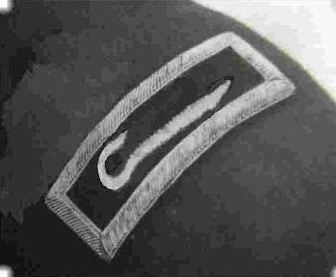

Your Chaplains exhort you as compatriots and our brothers to accept as TRUTH the following WORD as basic for living as “A SAR Gentleman. “
The following biblical passages explicate what God says is required of us.

- Hosea 6:6 - “I Yahweh/Jehovah, your LORD, desire my children's steadfast love (mercy, obedience and faith); and the knowledge of GOD rather than burnt offerings.”
Clearly, our FATHER wants HIS children to love only
THE MOST HIGH GOD.

- Psalm 127:1 - “Unless the LORD builds the house,
they labor in vain who build their house. “
Focus to do everything our FATHER'S way.
Always include our FATHER in all plans, decisions, and in life.

- Psalm 133:1 “Behold how good and pleasant it is for our FATHER to see the brethren dwelling together in unity. “
Compatriots, we must always know that we are a team, a family, and a brotherhood of like-thinking godly souls.
It is our first obligation to please our LORD.
Stand upon our ROCK and no storm or calamity will shake us.

2021
First US Army Approved Insignia for Army Chaplains.

A Pastoral Prayer

Gracious and Almighty God, Our loving Father,
We are grateful for your unswerving love for us,
for showing that love in fatherly Discipline and Compassion.
You have given us so many dedicated Patriots who have served this country to the very death with love and deep commitment.

We eternally thank you for our military, who, from the Revolutionary War on through the years have pledged their lives, their fortunes, and their sacred honor to win our independence. Many have pledged to continue to protect us against every foe.
Gracious loving Father, we give heartfelt thanks for the Military who serve us today. All of them our heroes.

Gracious Father, Teach us to be “A SAR Gentleman” to the core.
One who is carrying out our mission to represent you as we preserve and teach others the principles of Freedom and Liberty.

Through Christ we pray. AMEN.

Rev David J Felts, NSSAR Chaplain General 2019-2021, PASSAR Chaplain
Rev Robert K. Grumbling Jr., Assistant PASSAR Chaplain West
Rev Dr William Hearter, Assistant PASSAR Chaplain East
2021
A SAR Gentleman
Study One, Week One
Foundational Principle
“You shall love the Lord your God”
As you have looked over the materials, you can see that the word love is used many times. It is a very familiar word to all of us. We assume that we know what love is. There are probably thousands of songs about love. Most only consider the earthly, physical, and sexual type of love.
Stop for a moment and consider what love means to you.
How do you understand love?
How do you express love?
How do you want love for yourself?
Exploring this abstract concept of love will get us on the right track to continue our SAR Cross study and how love applies to the meaning of the cross and the spiritual values that we will consider.

Some meanings of love as a noun:
1 - a profoundly tender, passionate affection for another person.
2 - a feeling of warm personal attachment or deep affection, as for a parent, child, or friend.
3 - sexual passion or desire.
4 - affection for another person as “to be in love”.
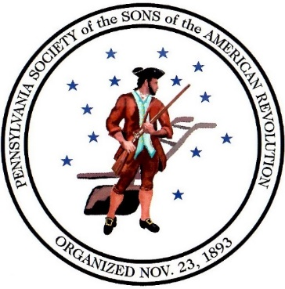

An Example:
Our revered Leader, General George Washington, struggled as he lived the example of loving God first. He sought to be ‘sold out’ to God in all he did. His day very often started with scripture reading and prayer, devoting himself to God, to His authority, to His leadership, and to His promise of leading him to see beyond the chaos of the war, beyond what seemed to be impending doom, and total loss of a nation. Washington worked hard as a young man in practicing these things, and even into old age.
In working on this first principle, we begin to see the seeds of hope starting to take root as we follow Washington’s example. Hope is a sure belief that God can and will do exactly what he has already promised. If we look in the Bible, in history, God has an unblemished track record, unlike ours. We must learn to trust through faith. That will allow hope to grow.
As Commanding General of the Colonial Armies, Washington practiced this hopeful viewpoint as he carefully led his men, made plans of attack, sought the good of his men in all his decisions. He always had a Chaplain close by. He regularly taught and urged his men not to use profane speech, to act right, to act as Gentlemen. He continually urged his officers to give a good strong example to the men by acting right and attending regular “Divine Services.”
And then he prayed, often writing his prayers in his journals. What a powerful example he set before his general officers, and before the men.
What quiet example do you give?
Does your life exemplify putting God first in all your affairs?
The first lesson of the SAR Cross is foundational. It informs everything that we do and think. The Cross Upright causes us to look up with the meaning,

“You shall love the Lord your God”.

2021
Study One, Week Two
Learning Love and Trust.
We must learn that love requires trust. We must learn to trust an all-powerful God that we cannot see. We must learn that the Sovereign Creator and ruler of the universe loves us and will guide us as we bow before Him.
Just as we love our families, our awesome God loves us jealously and will do everything necessary, in the right way to preserve us, show us His love, and care for us. – Forever.
Washington knew that the desires of his heart tended to be very self-centered. He struggled all his life to change that, to put God first. We can learn to do the same.
General Washington knew that authority requires respect. He learned that he, too must respect the authority of a great, sovereign God who would work out all the pieces of the puzzle and fit them all together the correct way. He also had to respect the authority of his officers. That respect was a powerful example to the men.
Washington knew that everything about the war did not depend on him alone. He understood that he must do his part to the best of his ability. He also knew that he must allow and encourage his officers and their men to do the same. Learning to show love, trust and respect are areas that we must work on if we expect to be exemplary and effective leaders. This is part of “Love the Lord your God”.
2021
Quietly, in your private place, work on these things.
Put God first in everything.
Acknowledge His Authority.
Respect and Honor His Position and right to do what He does for His reasons.
Respect and honor your compatriots, both fellows and officers as they try to do the same.
Learn how much God loves you and the gifts he has given you.
Learn how to use this great love to share with your Society brothers.
Following these actions will encourage the seeds of hope to take root in your soul.
2021
Study Two, Week Three
Foundational Principle
“Love your neighbor as yourself”

In his letter to the believers in Ephesus, the Apostle Paul wrote (Ephesians 5:29), “For no one ever hated his own flesh, but nourishes and cherishes it.”
We are reminded that part of our job, our calling, our responsibility is to care for others just as much as we care for ourselves.
It is easy to look about today and see plenty of negative examples. We get easily irritated by people who seem to be focused only on themselves. The person who goes to the famed seafood buffet at the local restaurant and takes a plate full of your favorite delicacies – and leaving none for you. The driver that is not paying attention and cuts you off on the interstate highway. A person paying more attention to a cell phone than he is to his driving or walking and hits into you.
If you watched the series, TURN, about the Revolutionary War, you probably had a similar reaction to a spy catcher, Major Simcoe. A particularly ruthless British Officer, he seemed to have no mercy on anyone. Sometimes even his own officers.
The British were well known for their horrible treatment aboard their prison ships off the coast of America. The imprisoned men, and some women, were badly treated at best. Many prisoners died within a year of their incarceration due to the horrific conditions and inhumane treatment aboard those ships.
Even during the important Revolutionary War, that treatment of prisoners of war was contrary to the way that General Washington acted. Washington had a deep respect for all life, even in war. He was reluctant to kill anyone or do them harm. But if it was necessary, as in war, it then became his obligation to do so that he may survive.
We read in Luke 10 about the Good Samaritan. A man was traveling along the road. Thieves came upon him, he was beaten, robbed, and left for dead. Two of the community leaders saw the injured man and passed by on the other side of the road. However, a hated man cared for the injured man with funds from his own pocket.
Caring for poor and injured travelers gave rise to some movements during the 10th and 11th centuries. Especially well known were the Knights of the Hospital of St John of Jerusalem, or Knights Hospitaller. They were charged with the care and protection of travelers. They had sworn an oath to protect the travelers no matter what. They carried just one offensive weapon, a sword, to be used only in matters that threatened the lives of themselves or other travelers. They were to care for and protect travelers and guide them safely to their journey’s end.
Shepherds for centuries have carried a special crooked stick. It was a multipurpose tool for saving an animal who wandered into the rocks or fell off a cliff. The crook was used to pull the injured animal to safety. The crook was also swung at wild animals that attacked the sheep. Finally, it was used as a walking stick.

We are like the Knights of the Hospital of St John of Jerusalem. We care for travelers along the road to true freedom, guiding them, helping them to learn the basic principles of freedom and liberty. We go into schools and teach as much as we can about the Revolutionary War.
We have poster contests to highlight events of the period. We hold the Rumbaugh Oration Contests, and several other events for youth. We honor the Military, EMS, Firemen, and Police for their service to humanity. These events are just a small part of what we do as SAR Gentlemen while we travel the road of freedom, guiding, and helping others on their journey to understand freedom and liberty. The programs become our examples to teach the basic principles of freedom and liberty.
However, that does not complete the words of the Second meaning of our emblem, the SAR Cross. Do you remember the Bible story of the Good Samaritan? It is about how a hated man came upon a man beaten and left for dead? Consider the lessons taught. (Luke 10:29-37, The Parable of the Good Samaritan.) The Knights of St. John of Jerusalem based their ministry on this biblical narrative which teaches us the way to freedom and liberty is through compassion and service to others. This is what our Great and Wonderful God urges us to do for our fellow travelers who seek the true meaning of freedom and liberty. These actions demonstrate the outward action of the inward virtues of “A SAR Gentleman.”

2021
We are to reach out to those in need of understanding the basic principles of freedom and liberty and help them learn as we are able.
Teaching history of battles, clothing, and weapons in schools.
Marching in Parades and honoring Veterans in period dress.
Honoring Patriots and our own fallen members.
Helping the public understand what freedom really is.
Helping men find their ancestors who played a part in the struggle for freedom and liberty in this great land.
Making in-person presentations as they are possible to present awards for contests, for proper flag etiquette, for serving the community.
Marking graves of veterans at Christmas and Memorial Day.
Dedicating graves of patriots who gave their lives for our freedom.

Take a few moments to quietly think about how you and your chapter reach out to support others.
Perhaps you may want to jot down a few personal notes for future reference.
Every now and then it may be good to review what you have written to gauge your growth. That backward glance may offer some insight in how you reach out to others and show compassion in their struggle to find the true meanings of freedom and liberty.

Questions for growth.
What do you do to display a clear example to others that shows something about the true meaning of freedom and liberty?
How do you act that displays to others your inner commitment to freedom and liberty?
How does your chapter participate in showing clear examples of promoting the principles of freedom and liberty?
What sorts of programs and activities do you have to promote freedom and liberty?
Do you and your chapter work with other groups to help them promote the basic principles of freedom and liberty?
Do you participate in honoring veterans, especially patriots?
In what programs do you participate?
Do you honor those who, like you, support and teach the principles of freedom and liberty?
How can you make good use of time, talents, and resources to further the goals and mission of the SAR in your area to reach out to others who struggle with understanding the basic principles of freedom and liberty?
The Second great meaning of the Maltese cross, the SAR Emblem is:
“Love your neighbor as yourself”

2021
Study Three, Week Four
The Four Core Values
The Four Core Virtues inform our basic philosophy of living, how we make decisions and how we do things. The Four Core Virtues also inform others about what kind of men we are.

We have lain the groundwork for A SAR Gentleman with the first two foundational principles represented by the two arms of the Maltese Cross, the SAR Emblem. We turn now to the second level which is built upon the previous studies. The second level, the four arms of the Maltese Cross, refer to a particular Core Value or Principle of A SAR Gentleman. The Four Core Values are as follows:
“Prudence, Temperance, Fortitude, and Justice”

We begin our discussion with the core value of Prudence.

As stated in the “Overview”, “Prudence is more than carefully doing things correctly. It means wisdom, the ability to carefully discern the appropriate course of action to be taken in each situation at the appropriate time and informed by the Bible’s wisdom and God’s teachings.”

During the Revolutionary War, as well as subsequent wars and conflicts, consideration of the enemy was central. The overall objective of the conflict
was treated as paramount. Intelligence was gathered on the enemy. Then came planning; several leaders reviewed the plans frequently.

As objectives became difficult in later wars, planning was increased. Less and less was left to haphazard preparation or quick judgments which would surely doom the project to failure before it started.

Prudence is a core value. Prudence, or wisdom is necessary to making viable plans. If you are a woodworker or carpenter, you probably know a good rule of thumb: “measure twice, cut once.” Having experienced that rule personally, I have learned the principle. I know this frustration. I have learned the wisdom of making a correction before doom raises its ugly head. Perhaps you have learned the same lesson experientially. It is very like “don’t count your chickens before they hatch.” The principle applies to a great many situations.

General Anthony Wayne discovered this lesson at least on one occasion. It may be supposition, but it appears that Wayne had a bit of a reputation of having a fiery temper, was masterful in a fight, able to hold his liquor, and being a womanizer. He knew how to take advantage of his opponent in a close face-to-face fight. He was also a successful surveyor and community planner when necessary. General Washington saw these characteristics in young Wayne and tried to urge him into becoming a good army officer.

Wayne was given the responsibly of defending against the British at Paoli, Pa. British Maj General “No Flint” Grey gained his nickname in that battle. Grey ordered his men to remove their flints from their guns and use only bayonets. This was a rather devastating method of debilitating and defeating the enemy. Although Wayne did nothing wrong procedurally, he lost the battle and several of his men in the fray. When the Military objective became Stoney Point, NY that guarded the Hudson River entrance, the tactics used against the Colonials in the Paoli, Pa loss came to mind.

Washington formed an elite force of nearly 1500 men to carry out an attack. It was ordered that the rifles be unloaded, flints removed. “Bayonets only” was a common British tactic and one that caused Wayne problems two years earlier. Now it would be used against the British.

Under the cover of darkness, the surprise attack at Stoney Point posed challenges. To avoid friendly fire, men wore pieces of white paper on their hats to distinguish each other in the darkness. Additionally, the first men arriving in the enemy camp called out a watch word to further identify each other.

In 25 minutes, the battle was over. The Continentals lost 15 men killed and 83 wounded. The British report said they suffered 20 killed and 58 missing. Many may have fallen into the Hudson and were lost to the sea. In total, nearly 1500 British were captured along with arms, cannon, and other accoutrements.

The plan was a success and proved to be the beginning of ensuing victories over the British. The plan further affirms the necessity of Prudence: doing due diligence in intelligence, planning, preparation, and implementation.

Prudence is a common approach from Revolutionary War battle plans to modern military plans to everyday business approaches. It is the beginning of the planning stage and becomes the bedrock of the work that follows.

Prudence has led the George Washington Chapter to participate in “Wreaths Across America.” Prudence then led the Chapter compatriots to seek ways to provide easier access to honor Revolutionary War patriots in cemeteries. In applying that core value, the George Washington Chapter’s program now provides easy access to patriots’ biographies using their smart phones.

If you have been part of the SAR for several years, you have seen the same steps used to move the Museum of the American Revolution at SAR Headquarters in Louisville, KY from dream to a world class brick-and-mortar presentation. That has meant a needs assessment, and included exploring the needs for a building, dividing the usable area according to purpose, and funding among others. At several steps in the process, Compatriots reviewed, rethought, and modified the project, guided especially by prudence.

2021

Without knowing it, you may have used prudence to guide your meeting plans and programs. You may have been part of someone else’s project as they used prudence to quietly guide them in their decisions.

Questions to guide your thinking
Have you been part of a plan or project that has used prudence to achieve success for your family, business, chapter, or society?
Perhaps you have used this method to plan for a new home or a special vacation?
Perhaps you were part of a state or chapter plan to reach out and promote the SAR and its mission of teaching the principles of freedom and liberty using the Patriot Chest?
Perhaps, like that George Washington Chapter of PASSAR, you have participated in conceiving and implementing a plan like installing informational signs at cemetery entrances using QR codes to display the listing of Revolutionary War patriots buried there.
Perhaps you have participated in the implementation of a state or chapter newsletter.
Or you have been part of the dues-collection process.
Give some quiet thought on how you rely on prudence in your personal life. Pay attention to both the positive and negative uses and results. It will enlighten you.

Prudence or wisdom is one of the Four Core Virtues of A SAR Gentleman.
2021
Study Four, Week Five
The Four Core Values represented by the Maltese Cross,
The Emblem of the SAR

The Second of the Four Core Values
Temperance

The Four Core Values inform our SAR philosophy of living, how we make decisions and how we do things. The Four Core Values also inform others about what kind of men we are.

The second Core Value is Temperance.
As stated in the “Overview”, Temperance represents more than being careful not to drink too much. This core virtue speaks to us of restraint, the practice of self-control both mental and physical; of abstention, discretion, and moderation which tempers the appetites. Plato considered translating temperance to mean sound-mindedness, the most important core value of several. St. Paul’s counsel to the brethren is to walk in the SPIRIT of God that He may carefully guide us and give us Temperance or Sound-Mindedness.

2021
Deuteronomy 25:3 states that a criminal should not receive more than forty lashes. This was law for centuries. It was for years considered to be one lashing short of inflicting death upon the offender, especially if bits of metal and potshards were tied into each of the thongs of the whip. That same practice had been followed by many a seafaring captain as well as a commanding soldier up to the time of the American Revolution.

In 1745, a British officer's sword, a symbol of his authority, could be broken over his head before final dismissal. That procedure is called “cashiering”. Today, it would be like a dishonorable discharge, being drummed out, or summarily discharged from military service. One of the considerations, even then, was that the punishment had to fit the crime. Many men’s lives may have depended upon that soldier carrying out those orders. Temperance would be required for humane treatment. What follows is an example from a narrative about Anthony Wayne.

General Anthony Wayne was sent to Pittsburgh in June 1792 to reorganize a hand-picked group Regulars to form a "Legion." His mission was to train the men for action in the Western Ohio territory to stop Indian raids on settlers. While in Pittsburgh, Wayne encountered a problem in keeping his men from drunken carousing and cavorting with the local women. Rather than subject the men to thrashings and all sorts of punishment, the core values of temperance and prudence guided Wayne in his travels down river from Pittsburgh to Legionville, or Logs Town. It was an old well-used Indian sight along the Ohio River near Baden today.

At this new sight, Wayne surveyed and established the first US Army Training Center. The men were kept busy with building and training, ending the men’s carousing, drinking, fighting, and womanizing.
This example demonstrates how temperance and prudence working in concert rectifies potential problems.
Temperance in making a sound-minded decision to not punish the men almost mindlessly nor to be lured into the problem itself.
Prudence, or Wisdom, in removing the temptation (the problem) as far as possible from the men’s easy reach/temptation.
Wayne called upon his previous skills in surveying the site, planning the community, and developing a plan to build, settle, and train the men.

Questions to guide your thinking
Have you been part of developing a plan using temperance, or sound -mindedness?
Have you ever prayed for wisdom and sound-mindedness to help you make decisions?
A habit of calling on our Great and Wonderful Father-God, for His help and guidance shows sound-mindedness, strength, and wisdom, not weakness.
This approach to sound-mindedness is a mark of a leader. It grows and becomes more evident as it is used. Do you use this approach regularly?
It would be good for you to carefully consider your approach to leadership.
Look carefully to see how temperance, or sound-mindedness plays a penetrating role in your approach and carrying out decisions and programs.

Temperance or sound-mindedness is the second of the Four Core Virtues of
A SAR Gentleman.

2021
Study Five, Week Six
The Four Core Values represented by the Maltese Cross,
The Emblem of the SAR.

The Four Core Values inform our basic philosophy of living, how we make decisions and how we do things. The Four Core Values also inform others about what kind of men are we.

The Third of the Four Core Values
Fortitude

Fortitude is more than the idea that we must protect ourselves against attacks. Fortitude assumes courage: forbearance, strength, endurance in confronting fear, uncertainty, and intimidation.

Fortitude is perhaps the cause of most fear among the Four Core Values. We have considered Prudence and Temperance. This study builds upon those two Core Values.
To use the vernacular of everyday parlance, this core value urges us to “put up or shut up” and to “stand tall” among men for the principles of truth, no matter what the consequences. However, we must stand in such a way that we keep our personal integrity and are careful not to harm another’s personal integrity. That can be difficult.
Fortitude is part of our Pledge of Allegiance, as well as the Oath of Office we take as members of the SAR, including the Pledge to the SAR.

“We the descendants of the heroes of the American Revolution who, by their sacrifices, established the United States of America, reaffirm our faith (belief) in the principles of liberty and our Constitutional Republic, and solemnly pledge ourselves to defend them against every foe.”

That last line is very powerful, “to defend them against every foe.” To make and keep our Pledge to the SAR takes a very well-developed core value of fortitude.

We live in a time when it is assumed that when we agree with another person, it is the same as accepting all that they stand for. That sort of reasoning is very popular today, but it is wrong, very dangerous, contrary to good reason, and very evil. The other person puts upon us the responsibility to change our beliefs to accept them and their beliefs, thus proving they are right. It seems that “being right” is a very important human need, regardless of the truth of the issue concerned.
When we do not agree with another person, he/she may take that disagreement as not only a challenge to his/her way of thinking but also a personal attack on him or her. That is not the way of true reason, and not the way of A SAR Gentleman.
When our founding fathers gathered at Carpenters Hall to debate and finally sign the Declaration of Independence in Philadelphia in 1776, they realized it would take tremendous fortitude. They had no further action necessary than to rely on their convictions to make this new experiment in freedom work. From John Adams and John Hancock to the Rev Dr John K Witherspoon and Dr Benjamin Franklin, they all agreed and relied upon their fortitude to assist them in their convictions.
These men finally were convinced of the truth of the situation. They had studied, debated, discussed, and concluded that the truth they shared for our new nation was articulated in the Declaration of Independence from England. Witherspoon is reported to have said, “[The Colonies] are ripe for it, or they shall wither on the vine.” The time for fortitude and action had arrived.
As Benjamin Franklin is credited with saying,
" We Must Hang Together Or Surely We Shall Hang Separately.”
Could he have meant this statement literally since, no doubt, the signers would hang for treason?
It took the fortitude of their convictions to sign the document and put themselves in harm’s way against mighty England to make that Declaration public.
They saw this as a duty. Duty is higher than one’s own personal survival or selfish interest. Their duty might even exact personal sacrifices of their lives. Consequently, the declaration concludes with these words,

“We pledge to each other our lives, our fortunes and our sacred honor.”

Honor and duty are superior to rights and personal self-interest. We as a nation seem to have lost the values of duty and honor today. It behooves each of us to relearn and teach those two values again to our Compatriots and our nation through the way we act and teach in presentations, in our chapter meetings, and in our public display of reverence for Military Veterans of all wars.

Fortitude: “Pledge to each other our lives, our fortunes, and our sacred honor.” Have you ever seriously considered the meaning of those words and your responsibility to live them?

To do live by these words we must use fortitude. We do not give up, we do not compromise, we do not equivocate, or capitulate. With fortitude, we must pledge ourselves with the well-known Scout Pledge, “On my honor, I will do my best to do my duty to God and Country.” It goes on saying that I will “keep myself physically strong, mentally awake, and morally straight”. The responsibility for fortitude rests upon each of us to develop, grow and maintain duty and honor throughout our lives.

FORTITUDE means that we stand for something, especially something good. That attitude was present during the Revolutionary War. To some degree, the soldiers had it, the officers had it, General Washington had it, and Congress had it. They had the fortitude of their convictions about the right path to freedom so that they could continue to press on, keep fighting against the most powerful military machine in the world at the time, to keep fighting for freedom.

I do not doubt that many colonials were scared out of their wits. They wanted freedom more than anything else. Commitment to the principles of freedom and liberty are not negated by the emotion of fear. Fear is a hurdle that must be used or overcome in the life and death struggle of a nation that produces a long-lasting “Liberty and Justice for all.”

It takes the fortitude of our convictions to continue acting right, no matter the situation. We must know what we value and express those convictions. Like General Washington and those patriots serving in the Continental Congress, we SAR descendants embrace those core values of liberty, freedom, and justice expressed in the Declaration of Independence. These are the same values expressed independently on the same day in the Tiadaghton Declaration signed by the Fair Play Men few miles from Jersey Shore, Pennsylvania along the West Branch of the Susquehanna River.

Do not misunderstand, fortitude is not stubbornness or hardheaded refusal to change no matter what. Fortitude can allow change and help us to become stronger when we are confronted with the truth, with the basic principles that support liberty and freedom itself. Fortitude pictures men who hold on to what they know is true in the face of many enemies.

Questions to guide your thinking.
Have your deep personal convictions been challenged by others?

Did it take fortitude for you to keep your head and emotions in check and not give in to what you know to be wrong?

Were you ever tempted to compromise your principles to agree with another person?

Do you see how demeaning and self-defeating it can be to compromise your very deep convictions?

Have you ever had your deep convictions challenged to the point that you are willing to change because you were convinced that the other position was right?

Look carefully at your deep convictions about life, liberty, and freedom. Make some private notes about your convictions that you may refer to later.

Then look carefully at your notes and ask yourself, “Do these convictions fit with being A SAR Gentleman?”

Do your convictions fit with the core principles of the SAR and its purpose and mission?

Do your core values help further the principles of liberty and freedom?

You may want to review your notes on the earlier core values of Temperance and Prudence. Think carefully about what your deepest core values are and how they help you live, act, and treat people. Does Fortitude play a defining role for you?

The Third of the Four Core Values
Fortitude

2021

Study Six, Week Seven
The Four Core Values represented by the Maltese Cross,
The Emblem of the SAR.

The Four Core Values inform our basic philosophy of living, how we make decisions and how we do things. The Four Core Values also inform others about what kind of men we are.

The fourth Core Value
Justice

Justice is not just doing what is right from our own perspective. It is also considered as fairness in all things; the Greek word also having the meaning righteousness.

Some writings from those who served in the Revolutionary War have claimed that General Washington was a tyrant, yet he was fair, he was just. Washington was often referred to as always seeking justice.
The Core Value of Justice is necessary for A SAR Gentleman. Justice is a process through which a gentleman always seeks to act ethically and morally in any given situation. Justice requires the implementation of the preceding three Core Values for proper application. Prudence, temperance, and fortitude are necessary core values if we wish to act as men of honor and integrity who act with Justice.
Consider an event in the life of King Solomon from the Bible described in 1 Kings 3. Two prostitutes came to the king with a dispute. Both had a child, but one rolled onto her child, and he died during the night. The dispute was about whose child was killed. Each claimed the living child.
Using the Wisdom that God had given Solomon, he said in verse-26-27, “Bring me a sword. … Divide the living child in two, and give half to the one and half to the other. Then the woman whose son was alive said to the king, because her heart yearned for her son, Oh, my lord, give her the living child, and by no means put him to death. But the other said, He shall be neither mine nor yours; divide him. ²⁷ Then the king answered and said, Give the living child to the first woman, and by no means put him to death; she is his mother.”
This resolution required prudence, temperance, and fortitude to arrive at a “just” conclusion. Men tend to think that God somehow injects a decision into a situation without any previous work done by the person, in this case Solomon. But if you look carefully into the history, you will see that much previous preparation had taken place during King Solomon’s life so that the King could advise the noted conclusion carefully and with justice.
It is popularly reported that General Washington was is such a deep depression one Christmas Eve over the lack of material goods that his soldiers badly needed. Supposedly, he reluctantly drafted a letter of resignation that would ultimately disband the rag-tag army. He went from his tent and men called out to him several Christmas greetings, which he returned. As he turned back to his tent, Washington reportedly burned his letter of resignation. His reasoned that if the men were somehow able to follow him and were so committed to the fight, he could continue to lead. He burned the letter and turned in for the night.
Judges 6:36 begins the story of how one soldier, Gideon put out fleeces to test the Lord. In Chapter 7, Gideon gathered an army of 30,000 to do the Lord’s fighting. After several encounters with the Lord, Gideon’s army was whittled down to 300 men. Trusting God required a lifetime of love, prudence, temperance, fortitude, and justice. At that point Gideon could trust the almighty to squeeze victory from a small band of soldiers.
If you read these stories for yourself, you will see how each core value builds upon the other. The specific words are not there, but the process is spread over several chapters. You can see how each core value is dependent upon the previous one to grow and make a difference in Gideon’s life.
Something similar can be your story when you have trained yourself in trusting God first and foremost, and then reaching out to your fellows, using prudence, temperance, fortitude, and justice in every decision you must make.
Following these four core values is far from making a list and checking it twice or listing pros and cons to see which is most pleasing. Neither is it flipping a coin attempting to find a magical answer to a problem. Nor is this tempting fate or karma to find an answer that has been floating about the universe for you to commandeer by your attention to it.
Each of your life decisions is built upon your training in the spiritual qualities that are represented by the SAR Maltese Cross. The four core values will guide you in service to God and Country and will positively affect you, your family, your chapter, the SAR, and the world in the good that you will do. The core values will have a tremendous positive affect on your leadership ability in any office that you fill for the SAR, or business for that matter. The core values become manifest in your identity as a SAR gentleman.
In a quiet place study these values and apply them to your life. Keep some personal notes so that you may see a positive difference in your attitudes, your actions, your leadership qualities, and your character. May Our Great and Wonderful God bless you in this study.

The Spiritual meaning of the SAR Cross, or
The Practical Application of the Spiritual Virtues of A SAR Gentleman,
Represented by the eight Golden Balls on the ends of each arm. Each circle stands for a spiritual quality, a spiritual virtue.

1 – To have Spiritual Contentment – Being “comfortably sold out” to one’s creator God.

2 – To Live without Malice – To have no hidden desire to do ill to anyone

3 - To Weep over Your Sins – Saying, “I am sorry”, and being sorrowful over hurting others and our FATHER in Heaven.

4 – To Humble Yourself at Insults – More than learning to hold our peace and moving on.

5 – To Love Justice – Being inflamed with a passion for doing the right things for ALL men, all the time, everywhere.

6 – To be Merciful – More than forgiving, also remembering no more.

7 – To be Sincere and Open-Hearted - Having honest, genuine, and open motives, and willing to learn more.

8 – To Suffer Persecution – Standing Firm with incorruptible principles, facing every evil.

Spiritual Virtues

Study Seven, Week Eight
The Spiritual Virtues represented by the Maltese Cross,
The Emblem of the SAR.
First Spiritual Virtue.
To have Spiritual Contentment

This study looks back to the very first study on the SAR Maltese Cross and the upright beam. Everything hangs on and is supported by the main beam of the cross. That main beam teaches us that God is in charge and reminds us that we must be committed to and content with His being “in charge” of everything, including us. Everything else hangs on that trust.
You will notice that we have also mentioned being “sold out to God” in several places. We know this will make some uncomfortable. With a careless glance, some might think a kind of religion seems suggested. That could not be farther from the truth.
This Spiritual Virtue, Spiritual Contentment, has to do with personal and spiritual integrity. We may call it Allegiance. There was a time when as a nation, we recited the Pledge of Allegiance to our national Flag in schools and at nearly every public event. That public affirmation represented spiritual integrity as well as solidarity with each another. We knew what each other stood for and what we stood for as a nation. We had just been trough a terrible war. Allegiance, integrity, and solidarity were very important.
In the early days of television, Cowboy and Indian programs were popular. Sometimes viewers observed Native Americans saying that the settlers “spoke with forked tongue,” that is, speaking from both sides of their mouth or being untruthful. When it was convenient, one would forget the promise and change the rules.
James 1:8 speaks of a “Double minded man being unstable in all of his ways.” Matthew 12:25, Mark 3:5, and Luke 11:17 all say that a kingdom or house “divided against itself cannot stand”. Those Biblical passages illustrate the problem with lack of commitment or contentment. The “double minded” man is not settled in his thinking, not content. Oh, yes, he has questions, but the very basic issues are not settled. The result is no integrity, no solidarity, no allegiance to anything or anyone. He is not content.
This spiritual virtue of spiritual contentment speaks directly about our commitment to God, about solidarity with God, about complete satisfaction with God, about unity with God, about contentment with God. These words describe the SAR Gentleman who has the very basic issues settled. This is the SAR Gentleman who is committed to the truth as we get it from God. This describes the SAR Gentleman who recognizes that God is God alone. This describes a man who is content to be an obedient, loving, creature/servant.
To have spiritual contentment is being convinced beyond the shadow of any doubt that God is God alone and will do what He has said and promised. It means that we do not go searching around here and there for some other meanings in life through entertainment, sports, or material possessions because we have found the fountain of meaning and truth in God alone. We are content with that. It does NOT mean that we cannot enjoy sports, entertainment, and material possessions. We just do not worship them, and they do not define the meaning of our lives.
The way we express that meaning may differ from others. Our worship styles may differ somewhat, but we have discovered deep meaning, solidarity, and union with the author and finisher of life itself. We are very satisfied and content at the center of our being.
Spiritual Contentment means that we have settled the important deep issues of life and we are committed without reservation to God’s way of seeing and doing things. We are settled, we are convinced to the point that we do not go from philosophy to philosophy, from religion to religion, searching out what ever may seem to give us a sense of deed satisfaction.
This is the person on whom we may count for integrity and consistency. This is a SAR Gentleman, a person who will not lead us around to get what he wants. This settled person has our back because he knows that you have his back. He is committed to the same deep issues that concern us. This settled SAR Gentleman desires us to succeed, do our best, and look good before others as much as he wants the same for his life.
The content and settled SAR Gentleman is one whose qualities drive the SAR in carrying out its mission and programs. He does not quibble about the basics or the projects and principles of Freedom. He is committed to them just as you and I are. He is willing to discuss any ideas about how best to carry out the programs for the good of the SAR. He strives to keep his focus on the overall picture and the overall mission to fulfill that picture.
The SAR Gentleman who has spiritual contentment is one who is leadership material. We see this spiritual quality in General George Washington when as a young man copied the “Rules of Civility and Decent Behavior…” and sought to implement them in every part of his life. This was a lifelong project of continual improvement for him. It should be the same for us.
Washington kept a Chaplain nearby to help him keep his mind focused on truth and on the main purpose rather than on the tempting and discouraging things of this life. We also see this spiritual quality as he chose Officers and sought to encourage them in the development of their character. We saw spiritual contentment while he addressed his men and urged them to refrain from degrading and sinful behavior so they could be good followers of their senior officers. And we saw his contentment and settled spirit as he urged his men and officers to avoid using cursing and foul language that further degraded them by this behavior.
General George Washington is an example of living for a higher purpose than simply getting by, a higher purpose than riding out the circumstances, a higher purpose than getting his own way, even a higher purpose than defeating and “sticking it” to the enemy.
Rather, we see someone who sought to promote helping others, having their backs, obeying authority, sharing goals in solidarity, allegiance, and unity.
This is the SAR Gentleman who has SPIRITUAL CONTENTMENT.

Have you settled the very basic issues of life?
Have you settled them to the point where you are content with who you are at the core of your being even though you know that you could use some adjustments and improvements here and there?
Are you satisfied with your example of showing Solidarity with Gods truth, and with unity with the Society and its mission?
Are you the SAR Gentleman who Leads others quietly by a strong example as General Washington did as he urged his men and followers so that they are on the same side and urged them to reach for and act for a similar higher purpose and goal?
Are you the SAR Gentleman who urges others to be so committed to the goals of the Society that each one knows that the other has his back?
Are you the SAR Gentleman who knows that all the details have yet to be worked out and that there is plenty of room for discussion and planning?
Are you the SAR Gentleman who is so committed to the purpose and goals of the SAR that you are willing to try your best to work with all kinds of people in achieving those goals?
Are you the SAR Gentleman who does not take defeat as the end of the road, but rather sees the beginning of a new road, still moving toward the same purpose and goal with plenty of room for discussion and planning?
Take some time for quiet reflection on your life and look at how your life shows others that you are spiritually content, at unity with our great Creator God who sustains us in all kinds of circumstances?
The first spiritual virtue represented by the SAR Maltese Cross is
“Spiritual Contentment.”

