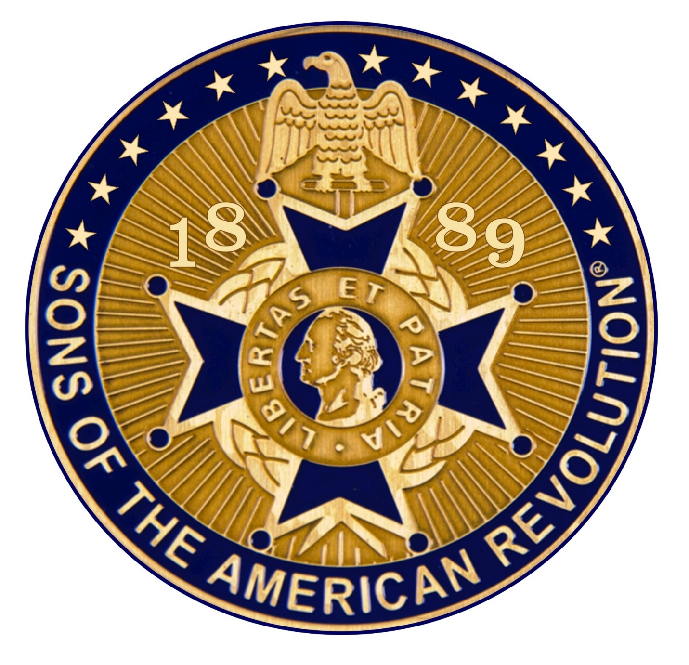
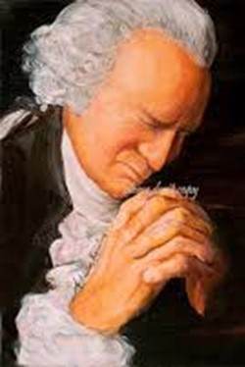
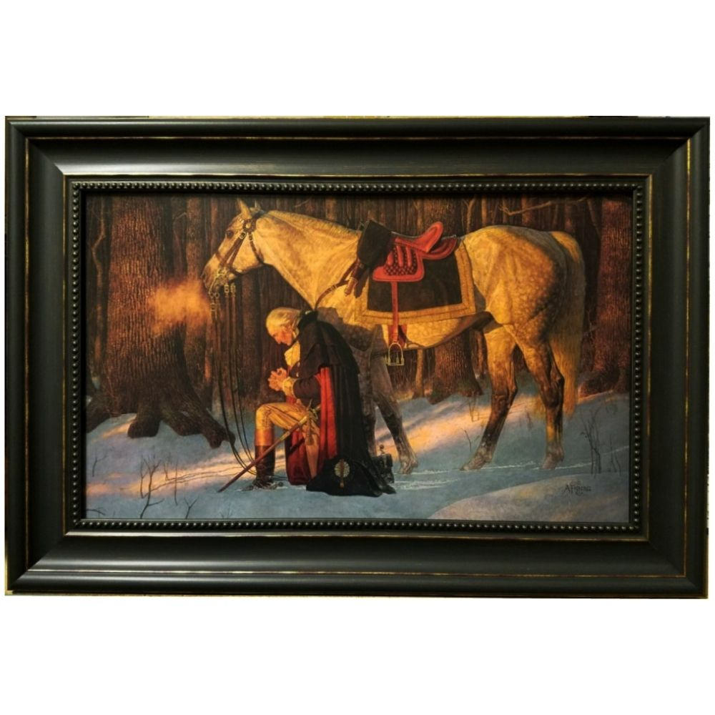
A SAR Gentleman

A Devotional Look at the SAR Cross
Officer Development Materials

Developed for PASSAR

The Pennsylvania Society
Sons of the American Revolution

For use by State and Chapter Officers
And ALL members
Who wish to become

A S A R Gentleman

Developed by:

Rev David J Felts, - Rev Robert K. Grumbling Jr., - Rev Dr William Hearter

PASSAR Chaplains

2021
Introduction

The purpose of this devotional look at the SAR Cross is twofold:

1: to offer an uplifting, devotional insight into the meaning of the SAR Maltese Cross for our growth and development as
A SAR Gentleman.

2: to deepen our walk with God to more than a cursory mention of God a few times a day. As we carry out that purpose, with daily study and meditation,
we will righteously impact ourselves, Chapters, PASSAR, the National Society,
our families, nation, and the world.

Each group under discussion is built upon the previous group. We need to follow the flow carefully so that we may accomplish lasting results.

May the God who led General George Washington to victory be gracious to you in your spiritual journey toward “A SAR Gentleman.”

DJF
Rochester, PA
2021

2021

Overview of Foundational Meanings

The SAR Cross is based on the Maltese Cross. This is the emblem we see on many of our SAR Badges and medals. It stands for several important qualities that are basic in the life of A SAR Gentleman.

These first two meanings are foundational.

1 - The Cross Upright beam leads us to look up with the meaning:
“You shall love the Lord your God” who is your FATHER.

2 - The cross horizontal beam reaches out and urges us to:
“Love our neighbor as ourselves”.

Overview of the Main Beams of the SAR Maltese Cross

The SAR Cross Symbol, the Maltese Cross and its meaning is obviously very blatantly putting “Providence” awareness first. The upright beam points up to the Sovereign creator with the meaning, “You shall love the Lord your God.” That is clearly teaching a ‘sold out to God’ attitude.

That is closely followed by the cross beam that is held up by the upright beam, reaching out to the side, teaching that we must reach out to others with the meaning, “Love your neighbor as yourself”. The Founding Fathers of the SAR were very conversant with these two foundational concepts.

Our mission is to teach these foundational tenets to the 1,700 plus members of the Pennsylvania Society SAR as well as to all 37,000 plus members of the National Society SAR so that each SAR Gentleman becomes an exemplar of those basic principles. That would have a transformative impact on the membership, our families, and the whole world!

When we look at the four arms of the Maltese cross, we are reminded of the
four core values of a SAR gentleman.

These four core values show values in which a SAR gentleman trusts and have been prominent since the fourth century: they are prudence, temperance, fortitude, and justice.

Prudence is more than carefully doing things correctly. It means wisdom, the ability to carefully discern the appropriate course of action to be taken in each situation at the appropriate time and informed by the Bible’s wisdom and God’s teachings.

Temperance represents more than being careful not to drink too much. This value speaks to us of both mental and physical self-control as well as abstention, discretion, and moderation which tempers the appetites. Plato considered translating temperance as sound-mindedness and as the most important virtue. St. Paul counsels brethren to walk in the Spirit of God from whence comes sound-mindedness that He may carefully guide us.

Fortitude is more than the idea that we must protect ourselves against attacks. It is also termed courage, forbearance, strength, endurance, and the ability to confront fear, uncertainty, and intimidation in oneself.

Justice is not just doing what is right from our own perspective. It is also considered as a pervasive view of fairness in all things. The Greek word also has the meaning righteousness.

The Four Core Values inform our basic philosophy of living, how we make decisions and how we do things. They show what makes “A SAR Gentleman”
tick.

The Four Core Values inform others about what kind of Man we are. If these are missing, others will sense a kind of emptiness and will tend not to seek our friendship or seek our advice, or membership in our organization. They will seldom take our opinions seriously or to heart as being something meaningful and worth treasuring. Others then, will tend not to count on us as one that will always do his well-thought-out best for the Society and for others.

The Four Core Values of Prudence, Temperance, Fortitude, and Justice
can be likened to computer programs that run behind the scenes, working on everything the computer does, but quietly in the background. Thus, the Four Core Values of Prudence, Temperance, Fortitude, and Justice affect everything “A SAR Gentleman” thinks and does.

2021

The Spiritual meaning of the SAR Cross, or The Practical Application of the Spiritual Virtues, represented by the Golden Balls on the ends of each arm. There are eight golden balls in all, and they represent the spiritual virtues of A SAR GENTLEMAN.

Each of the four arms has two round circles or golden balls on the end. Each golden ball stands for a spiritual virtue. The spiritual virtues are:

1 – To have Spiritual Contentment: Being comfortably “sold out” to one’s CREATOR God.

2 – To Live without Malice: To have no hidden desire to do ill to anyone.

3 - To Weep over Your Sins: Saying, “I am sorry,” and being sorrowful over hurting others as well as our FATHER in Heaven.

4 – To Humble Yourself at Insults: More than learning to hold our peace and moving on.

5 – To Love Justice: Being inflamed with a passion for doing the right things for ALL men, all the time, everywhere.

6 – To be Merciful: More than forgiving, also remembering no more.

7 – To be Sincere and Open-Hearted: Having honest, genuine, and open motives, and willing to learn and grow.

8 – To Suffer Persecution: Standing firm with incorruptible principles, facing every evil.

Introductory Message

As Sons of the American Revolution, we need to learn and relearn these basic principles represented by the SAR Cross. As compatriots, we need to practice these principles in all our daily activities and decisions. These basic principles make our personal freedom in the SAR and our national freedom work for everyone.

We believe that as Compatriots, we cannot serve our great God without growing in these principles. We also believe that every new chapter member should be encouraged to practice these SAR basic principles. In doing so, we become stronger in our own personal freedoms as well as exemplars of those for our nation.

Our great and wonderful FATHER GOD has given the National Society Sons of the American Revolution a privilege and a responsibility to carry this message of Freedom and Liberty to each of our children, the SAR, our nation, and the world. Our task is to teach the basic principles of freedom and liberty to ALL.

Deuteronomy 6:7 and 11:19 both instruct us to speak of and teach God’s laws to our children and family wherever we are and in whatever we do. The principles, To have Spiritual Contentment, To Live without Malice, To Weep Over Your Sins, To Humble Yourself at Insults, To Love Justice, To be Merciful, To be Sincere and Open-Hearted, To Suffer Persecution then become the laws that govern freedom and liberty. We must speak of them, live them wherever we are; teach them to family, friends, the SAR, the nation, and the world with a strong clear example.

It is our collective responsibility to preserve freedom and liberty in our generation and to pass it on to the next. In doing this, we will be doing a great service toward preserving freedom and growing the membership of the Sons of the American Revolution as well as serving our Great God whose Son we know as Jesus.

General George Washington was very insistent to his General Officers and his men that they each act as “Gentlemen”, even if they were in war. This insistence covered everyday activities as well as speech, treatment of others, including prisoners of war. He urged them to temper their speech to be respectful of each other, to correct their behavior so as not to be considered crass and disrespectful of others, and to attend “Divine Services” as they were offered to learn respect for their creator. When developed, these attitudes would encourage not only compassion for others but also strong bonds with fellow soldiers in battle.

2021

A Message from your Chaplains.

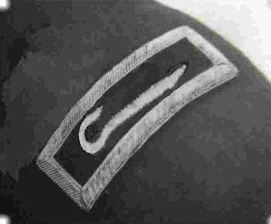

Your Chaplains exhort you as compatriots and our brothers to accept as TRUTH the following WORD as basic for living as “A SAR Gentleman. “
The following biblical passages explicate what God says is required of us.

- Hosea 6:6 - “I Yahweh/Jehovah, your LORD, desire my children's steadfast love (mercy, obedience and faith); and the knowledge of GOD rather than burnt offerings.”
Clearly, our FATHER wants HIS children to love only
THE MOST HIGH GOD.

- Psalm 127:1 - “Unless the LORD builds the house,
they labor in vain who build their house. “
Focus to do everything our FATHER'S way.
Always include our FATHER in all plans, decisions, and in life.

- Psalm 133:1 “Behold how good and pleasant it is for our FATHER to see the brethren dwelling together in unity. “
Compatriots, we must always know that we are a team, a family, and a brotherhood of like-thinking godly souls.
It is our first obligation to please our LORD.
Stand upon our ROCK and no storm or calamity will shake us.

2021
First US Army Approved Insignia for Army Chaplains.

A Pastoral Prayer

Gracious and Almighty God, Our loving Father,
We are grateful for your unswerving love for us,
for showing that love in fatherly Discipline and Compassion.
You have given us so many dedicated Patriots who have served this country to the very death with love and deep commitment.

We eternally thank you for our military, who, from the Revolutionary War on through the years have pledged their lives, their fortunes, and their sacred honor to win our independence. Many have pledged to continue to protect us against every foe.
Gracious loving Father, we give heartfelt thanks for the Military who serve us today. All of them our heroes.

Gracious Father, Teach us to be “A SAR Gentleman” to the core.
One who is carrying out our mission to represent you as we preserve and teach others the principles of Freedom and Liberty.

Through Christ we pray. AMEN.

Rev David J Felts, NSSAR Chaplain General 2019-2021, PASSAR Chaplain
Rev Robert K. Grumbling Jr., Assistant PASSAR Chaplain West
Rev Dr William Hearter, Assistant PASSAR Chaplain East
2021

